SOC Analytics Lab Report: Windows Endpoint Security Monitoring
Report By: Tanvi Sachin Itagikar

1. Executive Summary
This project was conducted in a controlled Windows 11 virtual machine environment to understand how Security Operations Center (SOC) analysts monitor endpoint activities and investigate security events. The main objective was to generate different authentication-related activities and verify whether Windows Security Logs correctly recorded these events.
Several common security scenarios were simulated, including successful logins, failed login attempts, user account creation, and account lockouts. These events were monitored using Windows Event Viewer and analyzed based on their Security Event IDs.
The project helped in understanding how SOC analysts detect suspicious activities such as brute-force attacks, unauthorized account creation, and abnormal authentication behavior by examining Windows security logs.

2. Environment Details
Operating System
- Windows 11 Virtual Machine
Monitoring Tool
- Windows Event Viewer
Log Source
- Windows Security Logs
Audit Configuration
- Local Security Account and Authentication Auditing

Purpose of Monitoring
- Detect authentication events
- Identify failed login attempts
- Monitor user account creation
- Track account lockouts
- Understand security event correlation

3. Core Investigation Tasks and Log Analysis
Task 1: Successful Authentication Log Tracking
Objective
To verify that legitimate user login activities are properly recorded in Windows Security Logs.
Event ID Monitored
4624 – An account was successfully logged on
Procedure
The user logged into the Windows system using valid credentials. After logging in, Windows Event Viewer was opened and filtered for Event ID 4624.
Findings
The system successfully generated a Security Event ID 4624, confirming that the login attempt was successful.
Important information captured included:
- Username of the logged-in user
- Logon Type
- Time of login
- Authentication details
The TargetUserName field displayed the username radha, confirming that the account had successfully authenticated.
SOC Relevance
Event ID 4624 is one of the most frequently monitored events in SOC environments. It helps security analysts establish a baseline of normal user activity. By understanding what legitimate login behavior looks like, analysts can more easily identify unusual or suspicious authentication attempts.
Analysis
Successful login events are generally considered normal behavior. However, SOC analysts often correlate these events with:
- Login time
- Login location
- User behavior patterns
- Previous failed login attempts
Unexpected successful logins occurring after multiple failed attempts may indicate a compromised account.

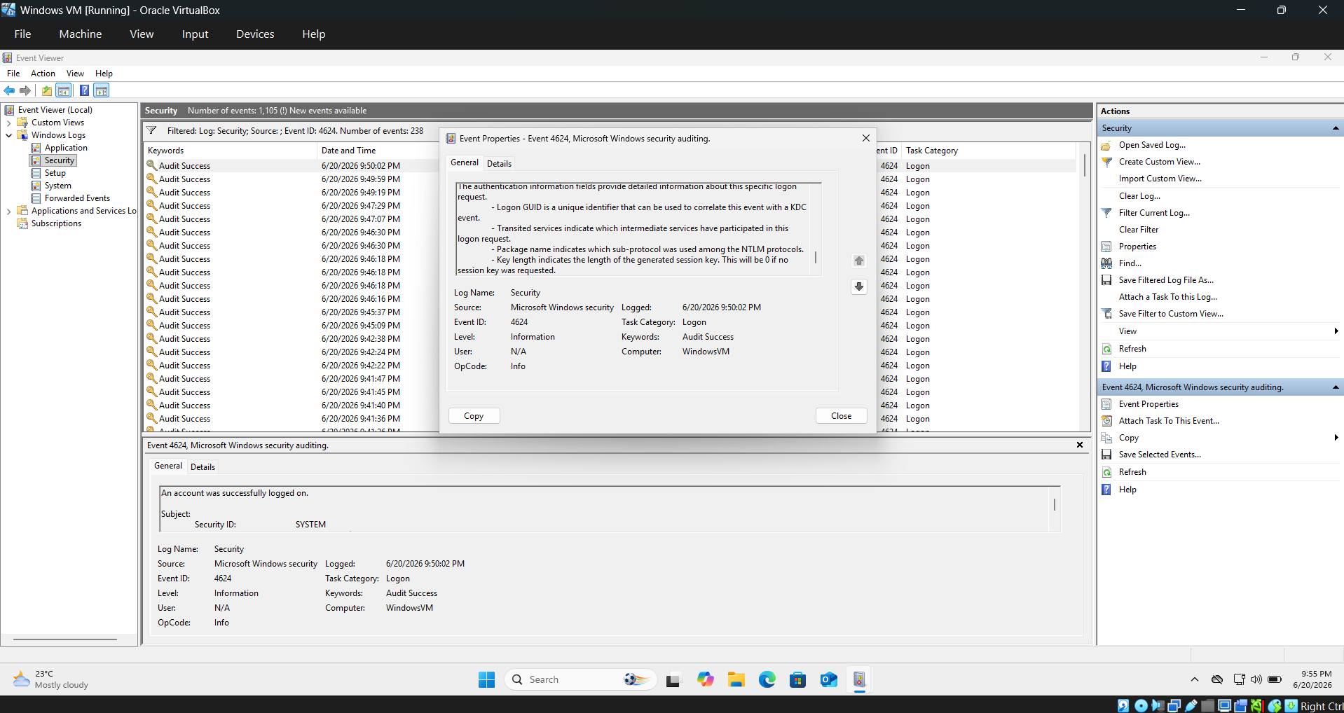

Task 2: Failed Logon Detection (Brute-Force Indicator)
Objective
To monitor and analyze failed authentication attempts that may indicate password guessing or brute-force attacks.
Event ID Monitored
4625 – An account failed to log on
Procedure
Multiple incorrect passwords were intentionally entered while attempting to log into the system. The resulting security events were then examined in Event Viewer.
Findings
Each failed login attempt generated Event ID 4625.
The event details contained:
- Target username
- Failure reason
- Logon type
- Source information
- Timestamp
Several consecutive failed logon events were observed, indicating repeated unsuccessful authentication attempts.
SOC Relevance
Event ID 4625 is one of the most important indicators of suspicious activity. A high number of failed logins within a short time period may indicate:
- Brute-force attacks
- Password spraying attacks
- Unauthorized access attempts
- User credential misuse

Analysis
While occasional failed logins are normal, repeated failures targeting the same account can be a sign of malicious activity. SOC analysts often create detection rules that trigger alerts when multiple 4625 events occur within a defined timeframe.
This event provides valuable insight into who was targeted and whether an attacker may be attempting to gain unauthorized access.

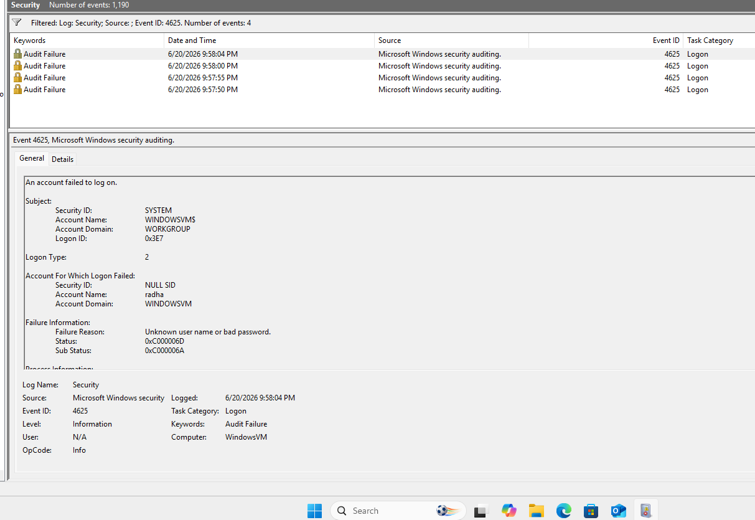

Task 3: Persistence Mechanics – New User Account Creation
Objective
To identify and monitor the creation of new user accounts that could potentially be used for persistence by attackers.
Event ID Monitored
4720 – A user account was created
Procedure
A new local user account named TestHacker was created using administrative privileges through the command:
net user TestHacker Password123 /add
After creating the account, Event Viewer was used to verify the corresponding security log.
Findings
Windows successfully generated Event ID 4720.
The event recorded:
- Name of the newly created account
- Account creator information
- Creation timestamp
- Security Identifier (SID)
The Security Log clearly showed that a new account named TestHacker had been created.
SOC Relevance
Threat actors frequently create hidden or unauthorized user accounts after gaining access to a system. These accounts allow attackers to maintain long-term access even if the original compromised account is removed.
Monitoring Event ID 4720 helps security teams detect:
- Unauthorized account creation
- Privilege escalation attempts
- Persistence mechanisms
- Insider threats
Analysis
Any unexpected user account creation should be investigated immediately. SOC analysts often correlate Event ID 4720 with administrator activities and change management records to determine whether the action was authorized.

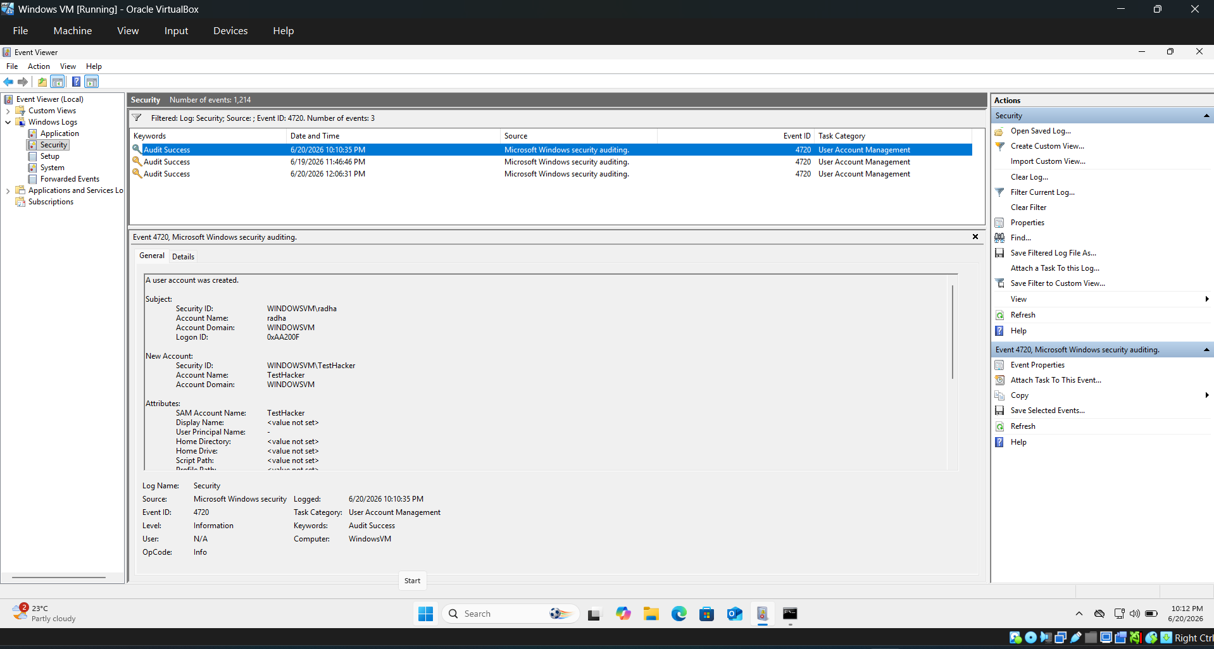

Task 4: Host-Based Defense – Account Lockout Trigger
Objective
To observe how Windows responds when multiple failed login attempts exceed the configured lockout threshold.
Event ID Monitored
4740 – A user account was locked out
Procedure
An account lockout policy was configured on the system. Multiple incorrect password attempts were then made until the account exceeded the allowed threshold.
Findings
After repeated failed login attempts, Windows automatically locked the targeted account and generated Event ID 4740.
The event included:
- Locked account name
- Time of lockout
- Source system information
- Security details
SOC Relevance
Event ID 4740 indicates that the system's security controls successfully prevented continued authentication attempts.
This event is commonly associated with:
- Brute-force attacks
- Password spraying attacks
- Misconfigured applications repeatedly using old credentials
- User account compromise attempts

Analysis
Account lockout events are valuable indicators of ongoing attacks. When Event ID 4740 is observed shortly after numerous Event ID 4625 failures, it strongly suggests an attempted brute-force attack.
SOC analysts investigate these events to determine:
- Who initiated the login attempts
- Which account was targeted
- Whether the attack originated internally or externally

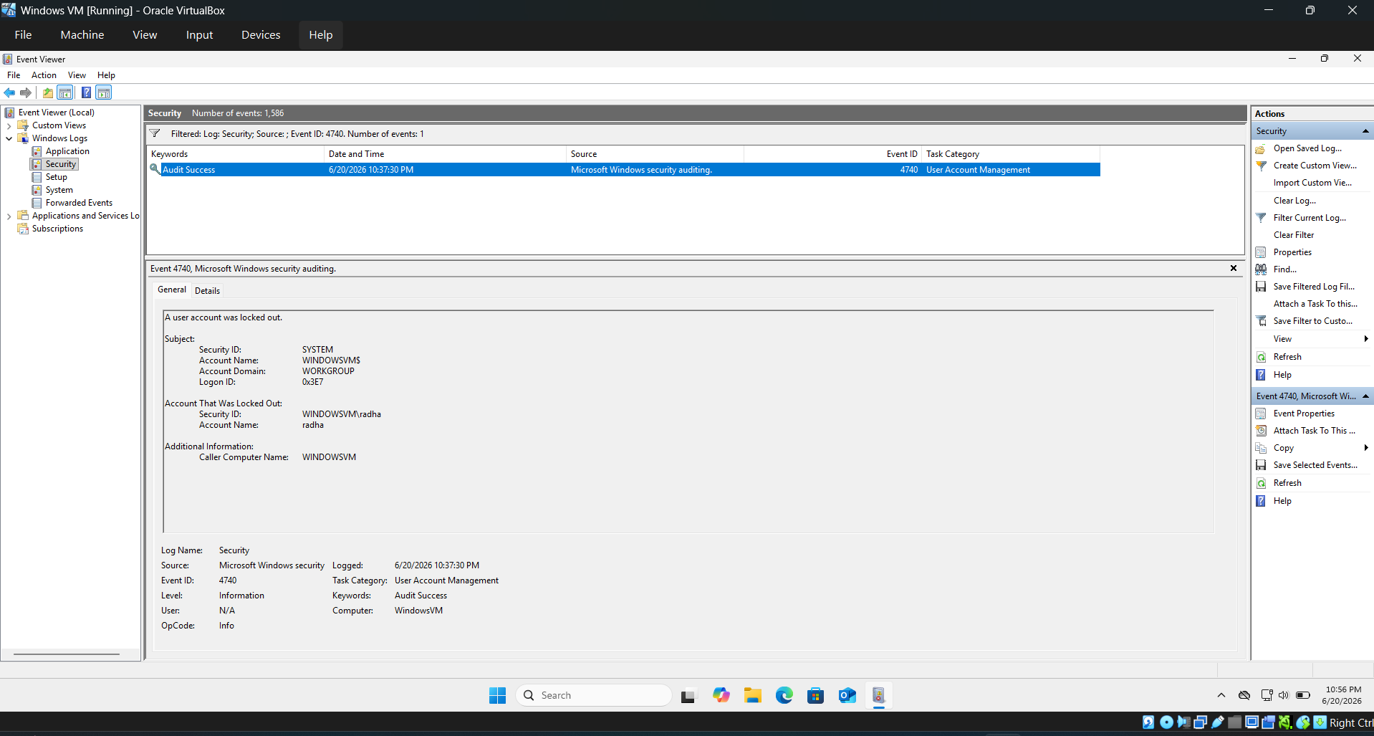

4. Conclusion and Key Takeaways
This project provided practical experience in Windows endpoint security monitoring and log analysis. By generating real authentication events and reviewing corresponding Security Event IDs, a deeper understanding of Windows auditing mechanisms was achieved.
Key Learnings
Understanding Normal Behavior
Event ID 4624 helped establish a baseline of legitimate user activity. Understanding normal behavior is essential for detecting anomalies.
Detecting Suspicious Activity
Event ID 4625 demonstrated how failed login attempts appear in security logs and how they can be used to identify brute-force attacks.
Monitoring Persistence Techniques
Event ID 4720 highlighted how new user account creation can be detected and investigated as a potential persistence mechanism used by attackers.
Evaluating Defensive Controls
Event ID 4740 showed how account lockout policies protect systems from repeated unauthorized login attempts.
Importance of Audit Policies
The project revealed that some critical events may not be logged unless proper auditing settings are enabled. Therefore, organizations should implement appropriate Group Policy configurations to ensure complete visibility into security-related activities.
Final Outcome
This lab successfully demonstrated the role of Windows Security Event Logs in endpoint monitoring and incident detection. The collected logs provided valuable visibility into authentication activities, user account management, and defensive security controls. These monitoring capabilities form the foundation of SOC operations and contribute significantly to effective threat detection and incident response.

